**INDIAN INSTITUTE OF TECHNOLOGY INDORE**

**AUTUMN SEMESTER 2023 (AY 2023-24)**

**Discipline of Metallurgical Engineering and**

**Materials Science**

**B.TECH. PROJECT**

**MID-TERM REPORT**

On

**Synthesis of NiMn2O4 for Photocatalytic Dye Degradation Application**



**SUBMITTED BY:**

**Akshita Mittal**

200005005

**UNDER GUIDANCE OF:  
Dr. Rupesh S. Devan**

Associate Professor, Metallurgical Engg. and Materials Science

**Table of Contents**

1. Introduction
2. Literature Gaps and Objectives
3. Experimental details
4. Results and discussion
   1. XRD results of powders prepared
5. Future scope
6. References
7. **Introduction**

Many organic contaminants from chemical, pharmaceuticals, and textile industries are disposed into the rivers and lakes directly. The water pollution, specifically caused by liquid organic pollutants, is more toxic and cause extreme harm to the aquatic eco-system. Among the Various industries, the untreated effluents released by the textile industry contains a diverse range of organic pollutants, surfactants, and alkali elements from which the most prevalent are textile dyes. Most textile factories discharges untreated organic dye contaminants directly into bodies of water, posing serious ecotoxicological threats as well as toxic effects on living organisms and environment. Azo dyes discharged into water reduce light penetration by interefering with the photosynthesis activity, impairing the performance of algae and growing aquatic plants. Furthermore, dyes ingested by fish and other living organisms have a negative impact on the health of both the fish and their predators. It also causes adverse effect on human health as this dyes are carciogenic and mutagenic. Over the recent decades, the exponential increase in the demand for potable water has further made it imperative to develop new and efficient ways for the treatment of wastewater. [1] To address this issue, several efforts are being taken by various researchers [2–7]. Among the various attempts, the photodegradation of organic compounds furnishes the easiest way to handle water pollution. Photodegradation of organic compounds is a cost-effective and environmentally friendly approach for handling water pollution, as it relies on natural Source of energy i.e. sunlight, minimizes the need for chemicals, and results in the breakdown of pollutants into harmless byproducts. It requires minimal infrastructure and offers scalability, making it suitable for various water treatment applications, while its continuous operation and long-term stability ensure consistent pollutant removal over time. The photocatalytic activity observed in TiO2 [8] has attracted the scientific community to explore suitable photocatalytic material to upgrade and expedite the wastewater treatment (i.e., dye degradation) efficiency. The photocatalytic dye degradation process relies on the formation of reactive oxygen species (ROS) by the absorption of solar energy greater than the bandgap of the catalyst material [9]. Hydroxyl (·OH) and superoxide (·O2−) radicals are well-recognized ROSs having oxidation potentials of 2.7 and -2.3 eV, respectively. The oxidation potential of organic compounds which is to be degraded varies between −1 to 2 eV [10]. This ROS plays a significant role in the oxidation and reduction reaction for the degradation of dye molecules. Decades of efforts have successfully produced a wide range of efficient semiconductor-based photocatalytic material, e.g., TiO2, SnO2, and ZnO, for the redox charge transfer process attributed to their electronic structure. These metal oxide semiconductors are broadly considered for efficient photo-assisted degradation and mineralization of many waterborne and airborne organic contaminants. However, their applications are still limited because of the wide bandgap, hence requires more energy (UV region) for the electron-hole pair production, but the solar spectrum contains only 5 % of UV radiation. [11]. To overcome the drawbacks of these first-generation photocatalysts, the scientific community has been exploring new effective photocatalyst that shows activity towards visible light radiation through maximum absorption (minimum wavelength). Such second-generation photocatalysts, i.e., WO3, Fe2O3, and Cu2O3, and heterojunction catalysts like WO3/NiWO4, Ag3VO4/g-C3N4, etc. are non-toxic in nature and highly photosensitive. Nevertheless, their low quantum yield due to fast electron-hole pair recombination and poor stability restricted their use in real-time applications [12]. Therefore, novel binary metal oxide photocatalysts with the chemical formula of AxByOz are being developed to address above mentioned problems. Among these various third generation photocatalysts, such as perovskites (A3+B3+O3, A2+B4+O3), A3+B5+O4 compounds with scheelite structures (such as tungstate, molybdate, or vanadate), and iron spinels (AB2O4), the Spinel-type compounds (AB2O4), where A is rare earth metal ion, and B is transition metal ion) are found suitable for photocatalytic application due to their ability to tailor the bandgap, and controllable structure. The nanostructured semiconductor metal oxides are a predominant photocatalyst, because of nanostructured materials having an interesting outcome owing to considerable changes in their physical properties. Therefore, the major aim of this research work is to synthesize a photocatalyst material suitable for visible light radiation, nontoxic nature, photochemically stable after long light exposure, and recyclable for photocatalytic dye degradation application.

Among various possible spinel compounds , NiMn2O4 was chosen due to its unique spinel structure which offers favourable properties for a photocatalyst due to their morphology, controllable structure, valence, composition, and excellent cyclic stability[13], low cost, and easy synthesis procedure [1]. Furthermore, manganese and nickel oxides are multifaceted, inexpensive and eco-friendly catalysts that have been highly used for the oxidation of various molecules in various applications, mainly photocatalytic activity, water oxidation, carbon monoxide oxidation, CO oxidation etc [1].

There are several approaches to prepare the spinnel compounds like hydrothermal, sol–gel, microwave-assisted hydrothermal method, emulsion and co-precipitation, etc. [14-17]. Ni–Mn–O in nano powder form can be obtained by a variety of techniques as mentioned above, in this work we have particularly explored the hydrothermal and co-precipitation routes. This is due to the various advantages offered by both the approaches. Co-precipitation technique offers advantages like having a viable approach, low-cost process, easy control on reaction parameters , economical process, can be easily doped at A and B site, ,, and there being no requirement of vacuum systems. [1]

Hydrothermal technique is another preferred approach due to its simplicity, and its ability to control the synthesis pressure and temperature along with the synthesized particle size and morphology. Hydrothermal synthesis technique usually incorporates water as the reaction medium [13]

Hence, NiMn2O4 ternary metal oxide in nano-powder form was synthesized via the co-precipitation method and the hydrothermal method, taking various combinations of precursor materials, and employing various hydrothermal and annealing parameters (temperature and time). In the co-precipitation synthesis process, Ethylene Glycol has been used as a structure directing agent.. The X-ray diffraction analysis has been studied to reveal the phase formation and to analyse the impurity peaks at various reaction parameters like temperature, time, concentration of precursor, etc., to obtain a pure phase of NiMn2O4. After optimisation of synthesis procedure to obtain pure phase, further work will involve the physiochemical, morphoilogical, and optical characterization of synthesized NiMn2O4 followed by investigation of the photocatalytic activity of the nano photocatalyst in the degradation of organic pollutants such as methylene blue (MB), Rhodamine B (RhB), Crystal Violet (CV), Malachite Green (MG), and Congo red (CR) using laboratory scale test reactor under Xenon lamp.

1. **Literature Gaps and Objectives**

Even though nickel manganite (NiMn2O4) has many advantages, only some works are reported for photocatalytic activity [18,19,20]. Thus, this work has been focussed on the synthesis of spinel-type nickel manganite by a facile route and to investigate its photocatalytic activity.

Objectives

1. To synthesize photocatalytic active NiMn2O4 compounds via the hydrothermal and co-precipitation method to study the photocatalytic dye degradation. Optimize various parameters such as temperature, solution concentration, reaction time and pH of the solution to achieve the best-optimized morphology.
2. To confirm their physicochemical properties using XRD, FESEM, UV-Vis spectroscopy, XPS, etc.
3. To optimize the photocatalytic dye degradation activity for various organic dyes like Methylene Blue (MB), Rhodamine B (RhB), Crystal Violet (CV), Malachite Green (MG), and Congo red (CR) using laboratory scale test reactor under Xenon lamp.
4. To determine the best-optimized efficiency of catalyst for various dyes by employing the pseudo first order kinetic model to get actual insight into water purification.
5. **Experimental Details**
   1. *Hydrothermal Procedure*

.

In a typical procedure, Nickel (II) and Manganese (II) precursors were taken in a 1:2 molar ratio and dissolved separately in 10 ml of DI water each. The Manganese (II) precursor solution was then transferred to the beaker of Nicker precursor solution. A 300 mmol solution of Urea was prepared in 10 ml DI Water, and a 120 mmol solution of Ammonium Fluoride (NH4F) was prepared in another 10 ml of DI Water. After this, Urea was added drop by drop to the precursor solution by using a burette, under constant stirring. Similarly, NH4Fwas then added to the solution and the solution was kept for stirring for another 30 minutes. The resulting mixture was then transferred into a 50 ml Teflon-lined autoclave reactor and placed in a hot air oven under multiple combinations of temperature and time in multiple experiments (as would be detailed further). Afterward, the stainless steel autoclave was allowed to cool naturally at ambient temperature. The resulting product was centrifuged with ethanol and DI water repeatedly. Final precipitate was obtained after placing the centrifuged sample in a petri-dish and left for drying overnight on a heating plate at 100℃. Final dried powdered sample was then placed in the furnace for annealing at various parameters (as would be detailed further). Sample was transferred carefully into a plastic vial and labelled properly. [13]

**Table 1:** Hydrothermal synthesis Parameters

|  |  |  |  |  |  |  |
| --- | --- | --- | --- | --- | --- | --- |
| Material | Ratio | Precursors | Hydrothermal  Parameters | | Annealing parameters | |
|  |  |  | Temp. (oC) | Time (h) | Temp. (oC) | Time (h) |
| NMO-1 | 1:2 | MnCl2, Ni(NO3)2 | 110 | 8 | 350 | 4 |
| NMO-2 | 1:2 | MnCl2, Ni(NO3)2 | 110 | 10 | 350 | 4 |
| NMO-3 | 1:2 | MnCl2, Ni(NO3)2 | 120 | 8 | 350 | 4 |
| NMO-4 | 1:2 | KMnO4, Ni(NO3)2 | 110 | 8 | 350 | 4 |
| NMO-5 | 1:2 | KMnO4, Ni(NO3)2 | 110 | 8 | 400 | 4 |
| NMO-6 | 1:2 | KMnO4, Ni(NO3)2 | 110 | 8 | 500 | 6 |
| NMO-7 | 0.9:2.1 | KMnO4, Ni(NO3)2 | 110 | 8 | 500 | 8 |
| NMO-8 | 1:1 | KMnO4, Ni(NO3)2 | 110 | 8 | 500 | 8 |

**Note : MnCl2-Mangnese Chloride,** Ni(NO3)2 – Nickel Nitrate Hexahydrate, KMnO4 – Potassium Permanganate.

* 1. *Co-Precipitation Synthesis*

In a general synthesis procedure, Nickel precursor and Manganese precursor was taken in 1:2 ratios and dissolved one by one in a solution of 90 ml of DI water and 10 ml of Ethylene Glycol (EG). After the homogenous solution was obtained by stirring, 1M KOH solution is added to the solution until the pH reaches ~ 11 in order for precipitation to occur. The solution is then continuously stirred for 7 h at room temperature. Then the resulting solution was centrifuged using ethanol and DI water alternately around 4-6 times. The precipitate obtained was then kept for drying on a petri-dish at 80 °C for 12 h. The dried powder then transferred to a crucible and placed in a muffle furnace at 700 °C with the holding time 3 h and ramp rate 5oC per minute.

Following are the various experimental parameters in co-precipitation synthesis.

**Table 2 :** Co-precipitation synthesis parameters

|  |  |  |  |  |  |
| --- | --- | --- | --- | --- | --- |
| Material | Ratio | Precursors | Solution Details | Annealing Parameters | |
|  |  |  |  | Temp. (oC) | Time (h) |
| NMO-9 | 1:2 | MnSO4, NiSO4 | 100% DI H2O | 700 | 3 |
| NMO-10 | 1:1 | MnSO4, NiSO4 | 100% DI H2O | 700 | 3 |
| NMO-11 | 1:1.5 | MnSO4, NiSO4 | 100% DI H2O | 700 | 3 |
| NMO-12 | 1:2 | Mn(Ac)2, Ni(Ac)2 | 10% EG | 700 | 3 |
| NMO-13 | 1:2 | Mn(Ac)2, Ni(Ac)2 | 10% EG | 700 | 3 |
| NMO-14 | 1:2 | Mn(Ac)2, Ni(Ac)2 | 10% EG | 500 | 8 |
| NMO-15 | 1:1 | Mn(Ac)2, Ni(Ac)2 | 10% EG | 500 | 8 |
| NMO-16 | 1:1.5 | Mn(Ac)2, Ni(Ac)2 | 10% EG | 500 | 8 |
| NMO-17 | 1:1.5 | Mn(Ac)2, Ni(Ac)2 | 10% EG | 500 | 8 |
| NMO-18 | 1:2 | Mn(Ac)2, Ni(Ac)2 | 10% EG | 800 | 16 |
| NMO-19 | 1:2 | Mn(Ac)2, Ni(Ac)2 | 10% EG | 800 | 24 |
| NMO-20 | 1:1.8 | Mn(Ac)2, Ni(Ac)2 | 10% EG | 800 | 24 |
| NMO-21 | 1:1.8 | Mn(Ac)2, Ni(Ac)2 | 10% EG | 800 | 16 |

**Note :** MnSO4 Mangnese Sulphate,NiSO4 – Nickel Sulphate, Mn(Ac)2 – Manganese Acetate, Ni(Ac)2 – Nickel Acetate, EG – Ethylene Glycol.

1. **Results and Discussions**
   1. *X-Ray Diffraction (XRD)*
      1. *NMO – Hydrothermal route results*

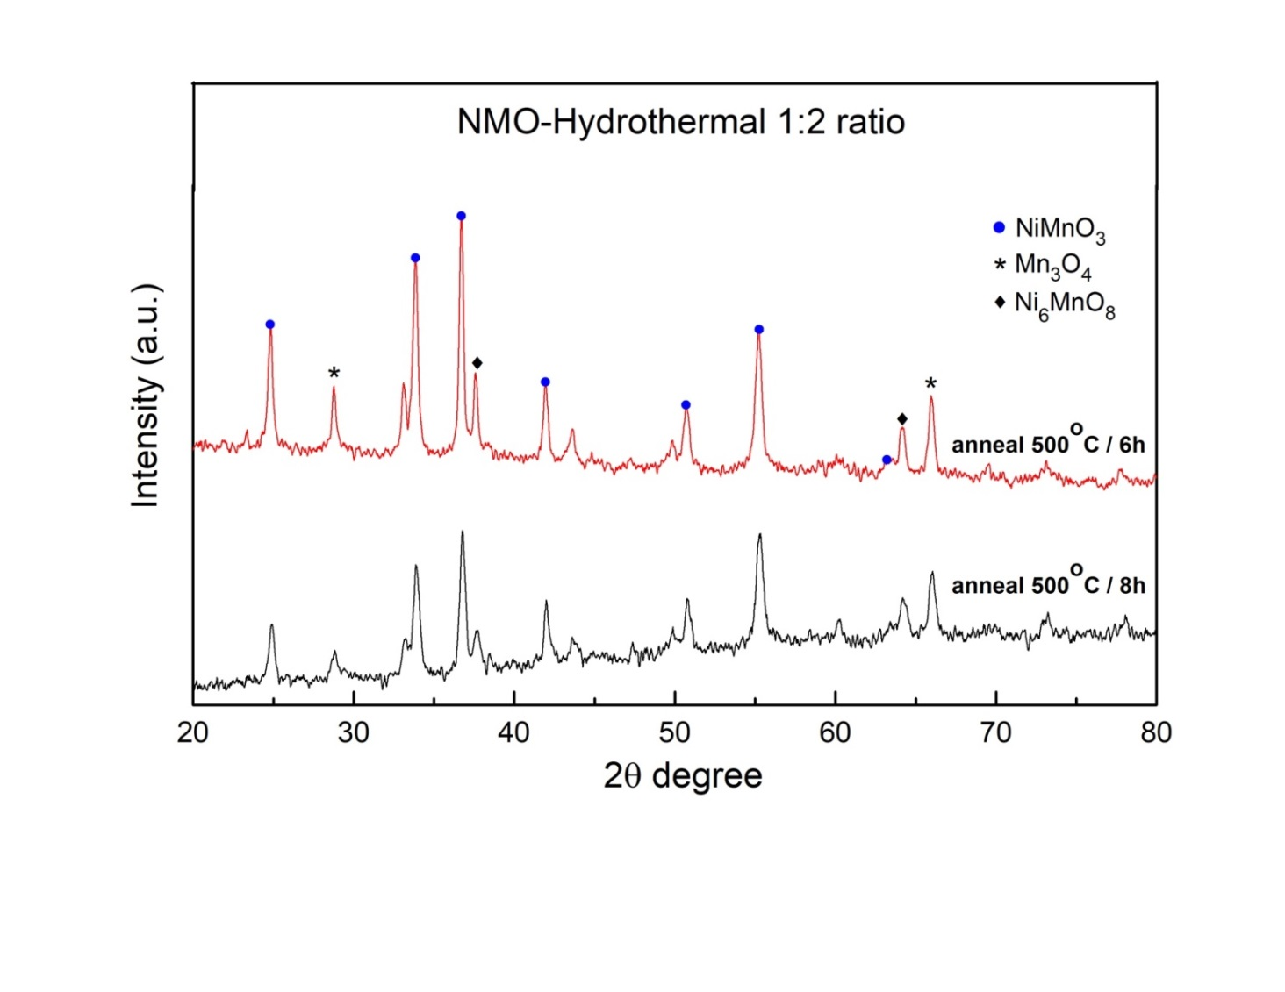

**Fig. 1.** XRD pattern of Hydrothermally prepared samples with different annealing parameters

Fig. 1 shows the XRD of hydrothermally prepared samples with different annealing temperature for metal precursor ratio of 1:2 with the same hydrothermal temperature and time. The majority of diffraction peaks present in the data (Fig. 1) correspond to the peaks of NiMnO3, along with some impurity peaks of Mn3O4 and Ni6MnO8. This indicates that the hydrothermal route was unsuccessful in the phase formation of NiMn2O4. Various ratios of precursors were also tried which gave the same results. The reason behind not forming the pure phase is unknown. As the phase is not formed after optimization of various reaction parameters, hence we have shifted to another synthesis procedure i.e. coprecipitation method.

* + 1. *NMO – Co-precipitation Route comparison between different Ni and Mn precursor ratios*

**Fig 2.** XRD pattern of samples prepared by co-precipitation route depicting variation in phase formed with different precursor ratios

Fig. 2 corroborate the XRD data of MNO synthesized by co-precipitation method by varying the ratio of metal precursor to 1:1, 1:1.5, and 1:2 and by keeping the other parameters same. For the 1:1 and 1:1.5 ratio there is no phase match but as the ratio changed to 1:2 the phase formation starts but with the some impurities. The diffraction peaks of the ratio 1:2 present in the data (Fig. 2) are indexed to the planes (103), (204), (105) and (305) (JCPDS no. 96-153-1195) of NiMn2O4, which indicates the successful formation of the same. These peaks are present along with some impurity peaks of Nickel Oxide, Mn3O4 and MnO2.

* + 1. *NMO – Co-precipitation Route comparison between different annealing parameters*

**Fig. 3.** XRD pattern of samples prepared by co-precipitation route with different annealing parameters and constant precursor ratio of 1:2

As from the XRD of 1:2 metal ratio and 700℃ annealing temperature (Fig. 2) the phase formation starts hence we fix the 1:2 ratio constant and increases the annaling temperature and time as shown in the Fig. 3. The diffraction peaks present in the data (Fig. 3) were indexed to the planes matching the phase of NiMn2O4, indicating the successful formation of the same. Various observations can be drawn from this graph:

* As annealing temperature and time is increased, peaks corresponding to the NiMn2O4 become sharper
* Peaks corresponding to NiMn2O4 also become more intense with increasing annealing parameters, while the impurity peaks become less intense
* The NiO impurities are eliminated with increasing annealing parameters.
* Major impurities are Manganese impurities, namely, MnO2 and Mn2O3.

1. **Future Work**
2. Further Optimisation will be done for the synthesis procedure –
   1. Hydrothermal method to be tried with the usage of Ethylene Glycol (EG),
   2. sample to be prepared without the usage of EG with the optimised annealing parameters to investigate the effect of EG on the phase formation,
   3. further experimentation to remove the Manganese impurities.
3. After optimisation of synthesis procedure to obtain pure phase, further work will involves the investigation of the photocatalytic activity of the synthesized NiMn2O4 NPs as nano photocatalyst in the degradation of organic pollutants such as methylene blue (MB), Rhodamine B (RhB), Crystal Violet (CV), Malachite Green (MG), and Congo red (CR) using laboratory scale test reactor under Xenon lamp. .
4. **References**
5. John Abel, M., Pramothkumar, A., Archana, V. *et al.* Facile synthesis of solar light active spinel nickel manganite (NiMn2O4) by co-precipitation route for photocatalytic application. *Res Chem Intermed* **46**, 3509–3525 (2020). <https://doi.org/10.1007/s11164-020-04159-y>
6. C. Burda, X. Chen, R. Narayanan, M.A. El-Sayed, Chem. Rev. 1025, 105 (2005)
7. X. Chen, S.S. Mao, Chem. Rev. 2891, 107 (2007)
8. Z. He, W. Que, J. Chen, X. Yin, Y. He, J. Ren, ACS Appl. Mater. Interfaces 6816, 4 (2012)
9. A. Abbasi, S.M.S. Sajadi, O. Amiri, M. Hamadanian, H. Moayedi, M. Salavati-Niasari, M.M. Beigi, Compos. B Eng. 175, 107077 (2019)
10. F. Namvar, S.K. Abass, F. Soofvand, M. Salavati-Niasari, H. Moayedi, Ultrason. Sonochem. 58,104687 (2019)
11. 6. M. Ranjeh, F. Beshkar, O. Amiri, M. Salavati-Niasari, H. Moayedi, J. Alloys Compd. 815, 152451
12. Akira Fujishima et. al, Nature, 1972, 238, 17-18.
13. Shuying Dong, et. al, RSC Advances, 2015, 5, 14610.
14. Hassan Anwer,et. al, Nano Research 2018.
15. F. Fresno, et. al, J. Mater. Chem. A, 2013
16. Jiejing Kong, et. al, Catalysis Today, 2019 (327), 47-63.
17. Samik Saha, Atanu Roy, Apurba Ray, Trisha Das, Mahasweta Nandi, Basudev Ghosh, Sachindranath Das, Effect of particle morphology on the electrochemical performance of hydrothermally synthesized NiMn2O4,Electrochimica Acta.
18. K. Kasinathan, J. Kennedy, M. Elayaperumal, M. Henini, M. Malik, Sci. Rep. **38064**, 6 (2016)
19. Y.S. Reddy, C.M. Magdalane, K. Kaviyarasu, G.T. Mola, J. Kennedy, M. Maaza, J. Phys. Chem. Solids **43**, 123 (2018)
20. M. Mahdiani, F. Soofivand, F. Ansari, M. Salavati-Niasari, J. Clean. Prod. **1185**, 176 (2018)
21. F. Mohandes, M. Salavati-Niasari, Ultrason. Sonochem. **354**, 20 (2013)
22. T. Larbi, K. Doll, M. Amlouk, Spectrochim. Acta Part A **117**, 216 (2019)
23. F. Sedighi, A.S. Nasab, M. Behpour, M.R. Nasrabadi, J. Nanostruct. **258**, 9 (2019)
24. G. Rekhila, Y. Gabes, Y. Bessekhouad, M. Trari, Solar Energy **220**, 166 (2018)